**DAILY ONLINE ACTIVITIES SUMMARY**

|  |  |  |  |  |  |  |  |  |
| --- | --- | --- | --- | --- | --- | --- | --- | --- |
| **Date:** | **31-5-2020** | | | | | **Name:** | **poojashree** | |
| **Sem & Sec** | **8th sem A sec** | | | | | **USN:** | **4al16cs065** | |
| **Online Test Summary** | | | | | | | | |
| **Subject** | | **iot** | | | | | | |
| **Max. Marks** | | **20** | | **Score** | | | **16** | |
| **Certification Course Summary** | | | | | | | | |
| **Course** | **Game development using pygame** | | | | | | | |
| **Certificate Provider** | | | **GUVI** | | **Duration** | | | **3.5hr** |
| **Coding Challenges** | | | | | | | | |
| **Problem Statement:**  **1**.  **monk watching fight** | | | | | | | | |
| **Status:completed** | | | | | | | | |
| **Uploaded the report in Github** | | | | | **yes** | | | |
| **If yes Repository name** | | | | | **Poojashree** | | | |
| **Uploaded the report in slack** | | | | | **yes** | | | |

**Online test**

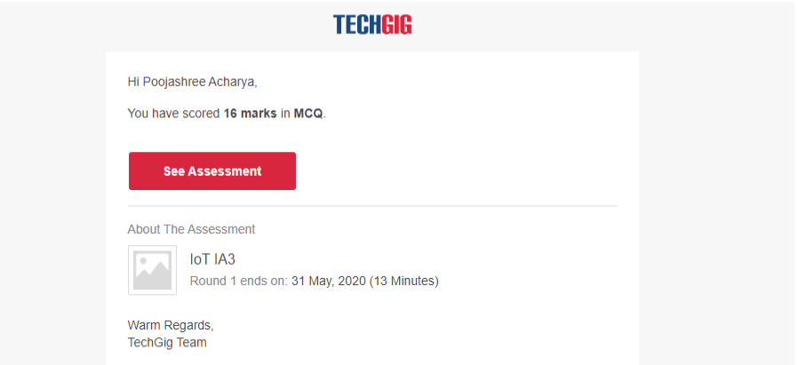

**Certification course**



**Coding**

**Program 1**

1. #include <stdio.h>
2. struct node{
3. int value;
4. struct node *left;
5. struct node *right;
6. };
7. struct node *newnode(int value){
8. struct node *makenode = (struct node*)malloc(sizeof(struct node));
9. makenode->value = value;
10. makenode->left = NULL;
11. makenode->right = NULL;
12. return makenode;
13. }
15. struct node *bst(struct node *root,int value){
16. if(root == NULL ){
17. return newnode(value);
18. }
19. else{
20. if(value <= root->value){
21. root->left = bst(root->left,value);
22. }
23. else{
24. root->right = bst(root->right, value);
25. }
26. return root;
27. }
28. }
30. void traverse(struct node *root){
31. if(root == NULL){
32. return;
33. }
34. traverse(root->left);
35. printf("%d\n",root->value);
36. traverse(root->right);
37. }
39. int max(int a, int b){return (a>b)?a:b;}
40. int height(struct node *root){
41. if(root == NULL){
42. return 0;
43. }
44. return 1+max(height(root->left), height(root->right));
45. }

48. int main(){
49. int n, i, j;
50. struct node *lulu;
51. scanf("%d",&n);
52. int *array = (int*)malloc(n*sizeof(int));
53. for(i=0;i<n;i++){
54. scanf("%d",&array[i]);
55. }
56. for(j=0;j<n;j++){
57. if(j==0){
58. lulu = newnode(array[0]);
59. }
60. else{
61. bst(lulu,array[j]);
62. }
63. }
65. printf("%d",height(lulu));
66. }